HUNTER BIRD OBSERVERS CLUB
Wader & Water Bird Counts WC 1/25
LOCATION: |  |  |  |  |  |  |  |  |  | Co-ordinates:  (if known) |  |  |  | …………….S……………….E
Wind direction: |  |  |  |  |  |  |  | Wind strength (use Still, Light Breeze, or Windy):
DATE: ….....….../….…......./..........…... |  |  |  |  | Start Time: |  |  |  | Finish Time: |  |  |  |  |  | Duration:  (mins)
OBSERVER(S):

This record sheet is designed for use in counts of shorebirds and waterbirds at locations in the Hunter Region. It lists the species more likely to be found within the Region. For uncommon and rare shorebirds, an Unusual Record Report Form (URRF) is likely to be requested; please make careful field notes at the time of the sighting. Use a new sheet for each distinct location visited. Send completed sheets to: Records Officer, Hunter Bird Observers Club Inc., P.O. Box 24 New Lambton NSW 2305. Please consider entering your results into Birdata too (as a Shorebirds 2020 survey).

WADERS

Species | Total | Tally Score
Pied Oystercatcher
Sooty Oystercatcher
Red-necked Avocet
Pied Stilt
Pacific Golden Plover
Black-fronted Dotterel
Masked Lapwing
Red-kneed Dotterel
Siberian Sand Plover
Double-banded Plover
Red-capped Plover
Eurasian Whimbrel
Far Eastern Curlew
Bar-tailed Godwit
Black-tailed Godwit
Latham's Snipe
Terek Sandpiper
Common Sandpiper
Grey-tailed Tattler
Marsh Sandpiper
Common Greenshank
Ruddy Turnstone
Red Knot
Great Knot
Sharp-tailed Sandpiper
Curlew Sandpiper
Red-necked Stint
Species not on Sheet (Note: an Unusual Record Report Form (URRF) will be required for any Uncommon or Rare Waders, so make careful field notes)

Species | Total | Tally Score

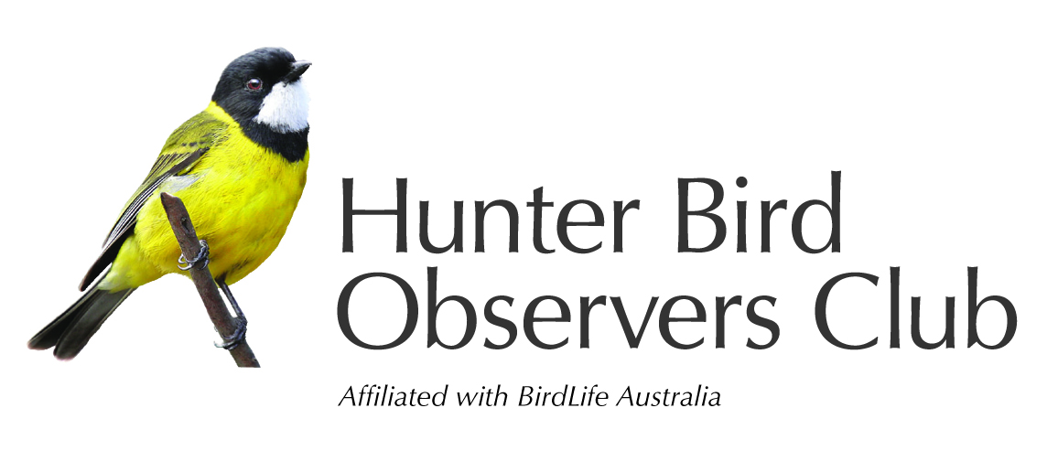
Your records assist the study and conservation of Australian native birds and their habitat.

Other waterbirds

Species | Total | Tally Score
Musk Duck
Black Swan
Maned Duck
Hardhead
Australasian Shoveler
Pacific Black Duck
Chestnut Teal
Grey Teal
Australasian Grebe
Hoary-headed Grebe
Dusky Moorhen
Eurasian Coot
Purple Swamphen
Australasian Darter
Little Pied Cormorant
Great Cormorant
Little Black Cormorant
Australian Pied Cormorant
Royal Spoonbill
Australian White Ibis
Straw-necked Ibis
Australian Pelican
White-faced Heron
Little Egret
Little Heron (Striated Heron)
White-necked Heron
Great Egret
Plumed Egret
Eastern Cattle Egret
Other species present

Species | Total | Tally Score
Little Tern
Caspian Tern
Australian Tern
Greater Crested Tern
Common Tern
White-fronted Tern
Silver Gull
Osprey
Whistling Kite
Brahminy Kite
White-bellied Sea Eagle

