HUNTER BIRD OBSERVERS CLUB
Wader & Water Bird Counts WC 1/20
LOCATION: |  |  |  |  |  |  |  |  |  | Co-ordinates:  (if known) |  |  |  | …………….S……………….E
Wind direction: |  |  |  |  |  |  |  | Wind strength (use Still, Light Breeze, or Windy):
DATE: ….....….../….…......./..........…... |  |  |  |  | Start Time: |  |  |  | Finish Time: |  |  |  |  |  | Duration:  (mins)
OBSERVER(S):

This record sheet is designed for use in counts of shorebirds and waterbirds at locations in the Hunter Region. It lists the species more likely to be found within the Region. For uncommon and rare shorebirds, an Unusual Record Report Form (URRF) is likely to be requested; please make careful field notes at the time of the sighting. Use a new sheet for each distinct location visited. Send completed sheets to: Records Officer, Hunter Bird Observers Club Inc., P.O. Box 24 New Lambton NSW 2305. Please consider entering your results into Birdata too (as a Shorebirds 2020 survey).

WADERS

Species | Total | Tally Score
Aust. Pied Oystercatcher
Sooty Oystercatcher
Red-necked Avocet
Pied Stilt
Pacific Golden Plover
Red-capped Plover
Double-banded Plover
Lesser Sand Plover
Black-fronted Dotterel
Masked Lapwing
Red-kneed Dotterel
Whimbrel
Far Eastern Curlew
Bar-tailed Godwit
Black-tailed Godwit
Ruddy Turnstone
Great Knot
Red Knot
Sharp-tailed Sandpiper
Curlew Sandpiper
Red-necked Stint
Latham's Snipe
Terek Sandpiper
Common Sandpiper
Grey-tailed Tattler
Common Greenshank
Marsh Sandpiper
Species not on Sheet (Note: an Unusual Record Report Form (URRF) will be required for any Uncommon or Rare Waders, so take careful field notes)

Species | Total | Tally Score

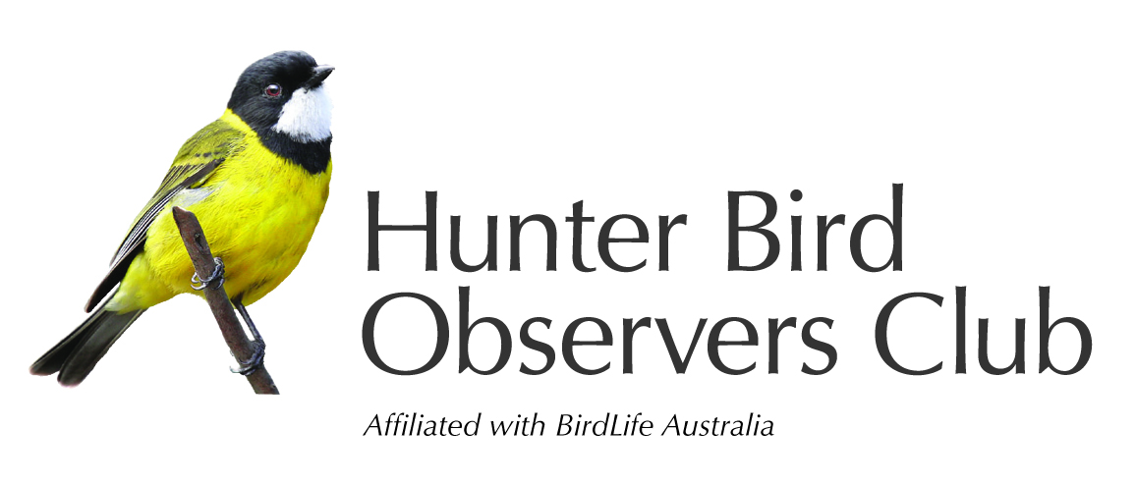
Your records are assisting the study & conservation of Australian native birds and their habitat.

Other waterbirds

Species | Total | Tally Score
Musk Duck
Black Swan
Australian Wood Duck
Hardhead
Australasian Shoveler
Pacific Black Duck
Grey Teal
Chestnut Teal
Australasian Grebe
Hoary-headed Grebe
Purple Swamphen
Dusky Moorhen
Eurasian Coot
Royal Spoonbill
Straw-necked Ibis
Australian White Ibis
Striated Heron
White-necked Heron
Cattle Egret
Great Egret
Intermediate Egret
White-faced Heron
Little Egret
Australian Pelican
Little Pied Cormorant
Great Cormorant
Little Black Cormorant
Pied Cormorant
Australasian Darter
Other species present

Species | Total | Tally Score
Silver Gull
Little Tern
Aust. Gull-billed Tern
Caspian Tern
White-fronted Tern
Common Tern
Greater Crested Tern
Osprey
White-bellied Sea-Eagle
Whistling Kite
Brahminy Kite

