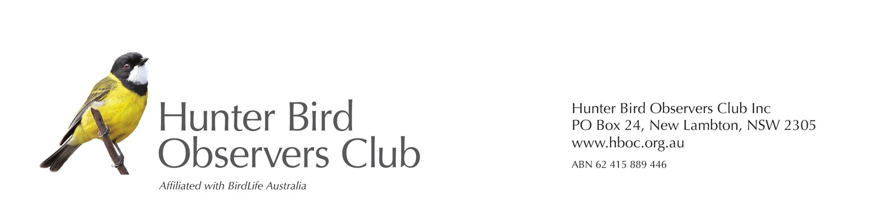
HBOC SUE and ED HAMONET AWARD for EXCELLENCE in BIRD EDUCATION:
APPLICATION FORM
FIRST NAME: |  | CONTACT PH:
LAST NAME: |  | MOBILE:
EMAIL:
POSTAL ADDRESS:

RELEVANT QUALIFICATIONS / SKILLS / EXPERIENCE
Please list details of relevant education and practical experience (paid/unpaid/volunteer positions)
PROJECT DETAILS
PROJECT TITLE:

LOCATION OF PROJECT:

Start date:
Completion date:
NAMES OF PEOPLE OF WHO WORKED WITH YOU:
NAME | ROLE | LEVEL OF INVOLVEMENT
BRIEF DESCRIPTION OF THE PROJECT:
Objectives and Justification – what was proposed to be achieved and why (max. 250 words)

Description – What was done (max. 250 words)

Significance of the project to education/conservation about Australian birds and the relevance for Hunter Region birdlife below (max. 250 words)

Demonstrated Outcomes – how the project was evaluated and a summary of evidence describing and showing the achievement of intended and unexpected outcomes (max. 10 dot points/500 words). References can be included as additional to the word count.

REFEREES
Please provide details of two referees below (who can comment on your project and your qualifications/experience):
Referee 1 Name:
Job Title:
Contact Number:
Referee 2 Name:
Job Title:
Contact Number:
By signing below, I agree to abide by the terms and conditions of HBOC’s award.
Please attach a brief CV, including any relevant qualifications/experience.

Signature of Applicant:
Date:
Signature of Nominee (if relevant):
Date:

