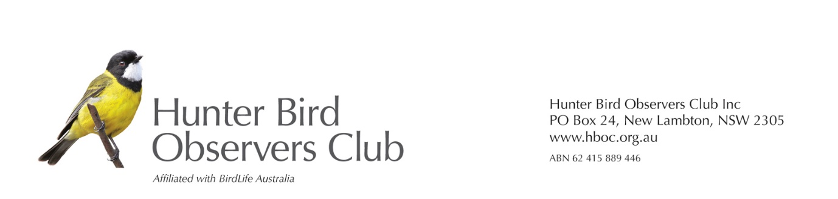
Mr Anton Peetz
Licensed Strata Management Agent
BCS Strata Management Pty Ltd
Locked Bag 22
Haymarket, NSW, 1240

Dear sir
Hunter Bird Observers Club (HBOC) is aware that Hunter Wildlife Rescue, with the help of NSW Ambulance, rescued six Cattle Egrets that were tangled in trees as a result of being caught in abandoned fishing line in the pond at Heritage Parc. Five of the birds were already dead and the sixth died the next day. Rutherford Ambulance did a wonderful job and cut down some of the branches that were dangerous to birds.
HBOC strongly supports Hunter Wildlife Rescue (HWR) and their concern for the danger to wildlife. We believe that Lynda Nolan from HWR contacted you as the strata management organisaton, and that you were sympathetic to her concerns, and we are grateful to you for that. It is important that something be done to prevent the recurrence of such an incident, as the Cattle Egret is becoming rare in the Hunter Region this summer and there are no breeding records anywhere in the Hunter. This situation will become more concerning for all water birds as we have more drought years in the future.
We are aware that this could be a difficult issue for you as fishing is a popular pastime and our club works closely with fishing organisations in their efforts to preserve the marine environment. We ask you to do whatever you can to preserve the natural environment for your residents. This could include a sign saying ’No Fishing’, or ‘All fishers in this area must carry a receipt
proving that they have paid the NSW Recreational Fishing Fee’. Some responsible landholders also provide a bin for disposal of fishing debris like fishing line and hooks. Details are available here: https://ozfish.org.au/projects/tangle-bins/.

You would not only be helping to preserve the life of Australia’s birds, but will also be improving the amenity for your residents who, I am sure, would appreciate your effort to preserve their pristine environment.

We will also send this information to Maitland City Council as they may be able to help.

Yours sincerely
Robert Stewart
On behalf of Hunter Bird Observers Club Conservation Committee.
Sent by email on
Reply to randmstewart@ozonline.com.au

