Will Brown
Coordinator Natural Environment & Resilience
Planning and Environment
Maitland City Council
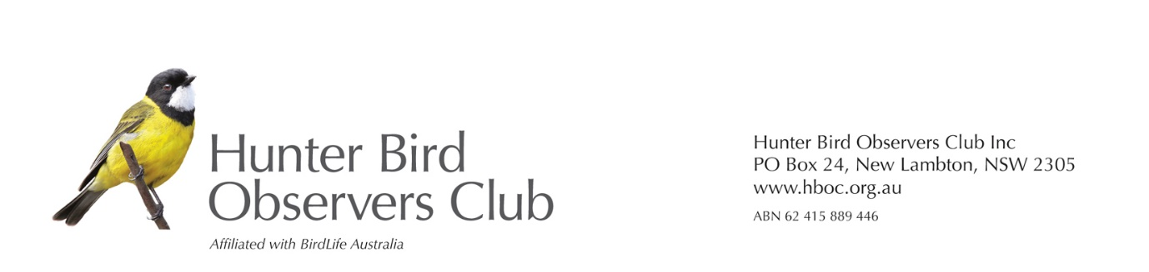
Dear sir
It has come to the attention of Hunter Bird Observers Club (HBOC) that Hunter Wildlife Rescue, with the help of NSW Ambulance, rescued six Cattle Egrets that were tangled in trees because of being caught in abandoned fishing line in the pond at Heritage Parc, Rutherford. Five of the birds were already dead and the sixth died the next day. Rutherford Ambulance did a wonderful job and cut down some of the branches that were dangerous to birds.
HBOC strongly supports Hunter Wildlife Rescue (HWR) and their concern for the danger to wildlife. We believe that Lynda Nolan from HWR contacted the strata management organisaton, and we believe that they were sympathetic to her concerns. It is important that something be done to prevent the recurrence of such an incident, as the Cattle Egret is becoming rare in the Hunter Region this summer and there are no breeding records anywhere in the Hunter. This situation will become more concerning for all water birds, as we have more drought years in the future.
We are aware that this could be a difficult issue for them and the council, as fishing is a popular pastime. We have suggested to them that they do whatever they can to preserve the natural environment for their residents. This could include a sign saying ’No Fishing’, or ‘All fishers in this area must carry a receipt proving that they have paid the NSW Recreational Fishing Fee’. Some responsible landholders also provide a bin for disposal of fishing debris like fishing line and hooks. Details are available here: https://ozfish.org.au/projects/tangle-bins/.

We are sending this information to Maitland City Council as you may be able to help them or provide advice about signage, and any other action they could take to prevent a recurrence of such an incident.

Yours sincerely
Robert Stewart
On behalf of Hunter Bird Observers Club Conservation Committee.
Sent by email on 18 December, 2024
Reply to randmstewart@ozonline.com.au

