HUNTER BIRD OBSERVERS CLUB
Wader & Water Bird Counts WC 1/16
LOCATION:
Co-ordinates:  (if known) | …………………….S…………………….E |  |  |  |  |  |  | HBOC Grid No:  (if known) |  |  |  | DATE: |  |  | ....….../…......./....…...
Weather Conditions: |  |  |  |  |  |  |  |  |  | Start Time: |  |  |  | Finish Time:
OBSERVER(S):

This record sheet is designed for use during counts of shorebirds and waterbirds at locations of interest in the Hunter Region. It lists the species more likely to be found within the Region. For uncommon and rare shorebirds, an Unusual Record Report Form (URRF) is likely to be requested; please make careful field notes at the time of the sighting. Use a new sheet for each distinct location visited. Send completed sheets to: Records Officer, Hunter Bird Observers Club Inc., P.O. Box 24 New Lambton NSW 2305.

WADERS

Species | Total | Tally Score
Aust. Pied Oystercatcher
Sooty Oystercatcher
Red-necked Avocet
Black-winged Stilt
Pacific Golden Plover
Red-capped Plover
Double-banded Plover
Lesser Sand Plover
Black-fronted Dotterel
Masked Lapwing
Red-kneed Dotterel
Whimbrel
Eastern Curlew
Bar-tailed Godwit
Black-tailed Godwit
Ruddy Turnstone
Great Knot
Red Knot
Sharp-tailed Sandpiper
Curlew Sandpiper
Red-necked Stint
Latham's Snipe
Terek Sandpiper
Common Sandpiper
Grey-tailed Tattler
Common Greenshank
Marsh Sandpiper
Species not on Sheet (Note: an Unusual Record Report Form (URRF) will be required for any Uncommon or Rare Waders, so take careful field notes)

Species | Total | Tally Score

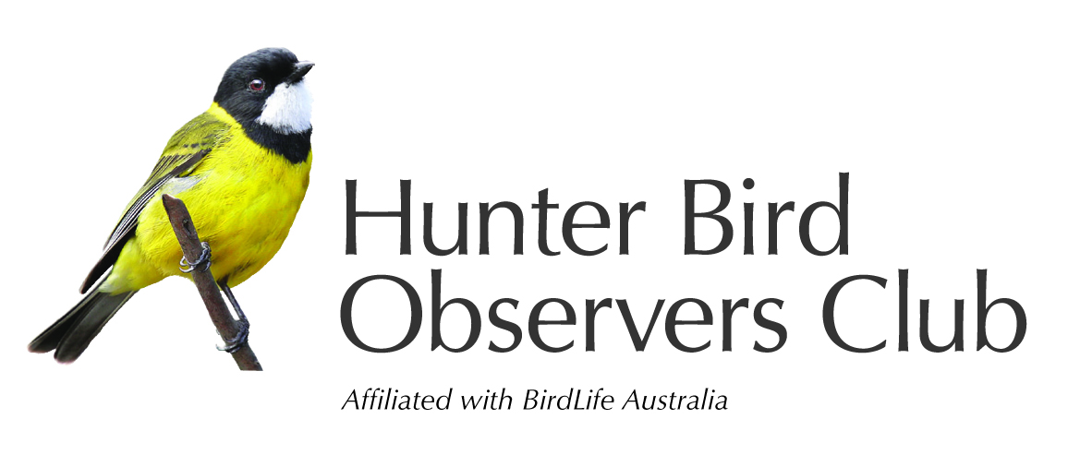
Your records are assisting the study & conservation of Australian native birds and their habitat.

Other waterbirds

Species | Total | Tally Score
Black Swan
Hardhead
Australasian Shoveler
Pacific Black Duck
Chestnut Teal
Grey Teal
Musk Duck
Australian Wood Duck
Australasian Grebe
Hoary-headed Grebe

Purple Swamphen

Dusky Moorhen
Eurasian Coot
Australian Pelican
Striated Heron
Cattle Egret
White-necked Heron
Great Egret
Intermediate Egret
White-faced Heron
Little Egret
Australian White Ibis
Straw-necked Ibis
Royal Spoonbill
Little Pied Cormorant
Great Cormorant
Little Black Cormorant
Pied Cormorant

Australasian Darter
Other species present

Species | Total | Tally Score
Silver Gull
Little Tern
Aust. Gull-billed Tern
Caspian Tern
White-fronted Tern
Common Tern
Crested Tern
Osprey
White-bellied Sea-Eagle
Whistling Kite

